Character and Byte Streams in Java

Stream

A stream is a method to sequentially access a file. I/O Stream means an input source or output destination representing different types of sources e.g. disk files.The java.io package provides classes that allow you to convert between Unicode character streams and byte streams of non-Unicode text.

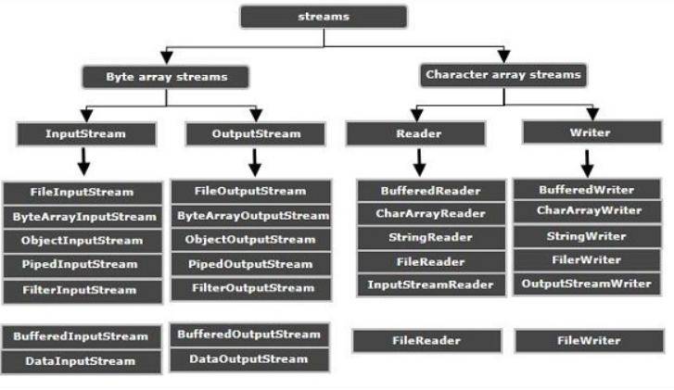

Character Stream

In Java, characters are stored using Unicode conventions. Character stream automatically allows us to read/write data character by character. For example FileReader and FileWriter are character streams used to read from source and write to destination. In Java, characters are stored using Unicode conventions. Character stream is useful when we want to process text files. These text files can be processed character by character. A character size is typically 16 bits.

Byte Stream

Byte streams process data byte by byte (8 bits). For example FileInputStream is used to read from source and FileOutputStream to write to the destination. Byte oriented reads byte by byte. A byte stream is suitable for processing raw data like binary files.

Differences between Character and Byte Stream

Character Stream | Byte Stream
Character stream classes handle characters. | Byte stream classes read/write byte stream data
Character stream classes accept character array as parameter. | Byte stream classes accept byte array as parameter.
Character stream classes handles all the Unicode characters , comes handy for internalization, comparatively efficient that Bytestreams. | Byte stream classes cannot handle Unicode characters.
Names of character streams typically end with Reader/Writer. | Names of byte streams end with InputStream/OutputStream

